metin içeren bir resim

Açıklama otomatik olarak oluşturuldu

**SE 403 – PROJECT MANAGEMENT**

**TERM PROJECT REPORT**

|  |  |
| --- | --- |
| 160706030 | Damla Alpan |
| 170706901 | Melih Cüneyter |
| 170706906 | Burak Tugay Sür |
| 170706029 | Doğukan Çağrı Destegüloğlu |
| 180706903 | Yeşim Gerdan |
| 180706016 | Ege Nur Yeşil |

**Advisor: Prof. Dr. Ensar GÜL**

**İstanbul, 24.03.2021**

İçindekiler

1. Examining The Code Files To Find Its Shortcomings 3

2. Project Description To “Readme” File In GitHub 4

3. Searching Development Language 6

a) What is Node.js? 6

b) Why Node.js? 6

c) What Can Node.js Do? 7

d) What is a Node.js File? 7

Blocking I/O 8

Non-blocking I/O 8

4. Implementation of Node.js 9

1. How To Implement Node.js ? 9

2. Which Environment Should We Choose? 9

3. Node.js Project Architecture 9

5. Asking The Client Requirements About App 10

6. Iterating And Testing 11

7. Last And Next Week's Working Plan 12

# Examining The Code Files To Find Its Shortcomings

Estimated Duration : 2 Days  
Actual Duration : 2 Days

Before we get started, there are major shortcomings in the source code provided on Github. How to install and run this project on localhost is not explained. The project is mainly written in Javascript and NodeJS. In order for NodeJS files to run smoothly in the system, the *'Yarn'* library developed by Facebook should be used.

Since there are no explanation lines in the program, the necessary research has been done and it will take time to complete. In order for the program to run on localhost, first of all, **"http: // localhost: 8180"** must be added to the **"start_url"** variable in the *manifest.json* file. This command will make the program run on localhost.

How to control the system in case of not loading or encountering any problems is provided with a library.

The file structure that the system will use during the installation is as follows. It is formatted to be ***Public_URL*** and ***Folder name***. If a different file structure is encountered, the system will not work.

const publicUrl = new URL (process.env.PUBLIC_URL, window.location.href);

if (publicUrl.origin! == window.location.origin) {

File checking is also done in index.html. Your files and subfolders should be in the same order. You should also check the file path and the location of your subfolders from here. Otherwise, your program will not work.

%PUBLIC_URL%/manifest.json

***Manifest.json***, It is the file in which basic metadata about the application extension such as name, version is used and at the same time its functionality is specified (background commands, content commands, browser actions).

Basic interface updates of the system will be performed under the *'src'* folder. *'Home.css'* is the style file of the application's first landing page. The styles of those that are planned to be shown on the first page will be edited here. Items that are planned to be displayed on the homepage can be updated via *'Home.js'.*

At this point there are a lot of documents that are missing from the application. Additionally, there are too many functional and visual errors. The project will be developed within the specified time until the end of the term, its functionality and interface will be improved.

# Project Description To “Readme” File In GitHub

Estimated Duration : 2 Days  
Actual Duration : 2 Days

We started the week with task planning. Here our duties with person and process time information. My task was to prepare a document to make our project understandable. The open source project we used was not clear enough, it was just mentioned superficially, I explained the steps of downloading the necessary packages for the project to work, and I put this document in our group on github.

metin içeren bir resim

Açıklama otomatik olarak oluşturuldu

metin içeren bir resim

Açıklama otomatik olarak oluşturuldu

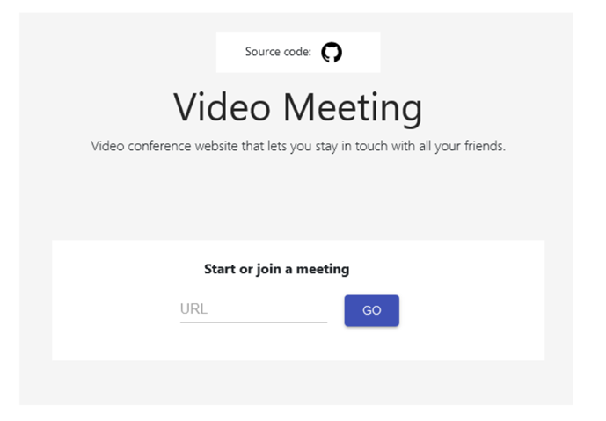

# Searching Development Language

Estimated Duration : 2 Days   
Actual Duration : 2 Days

## What is Node.js?

Node.js is an open source server. It also works on platforms such as Windows, Linux, Unix, Mac Os X. Node.js uses JavaScript on the server and it is free.

## Why Node.js?

A common task for a web server can be to open a file on the server and return the content to the client.

Here is how PHP or ASP handles a file request:

1. Sends the task to the computer's file system.
2. Waits while the file system opens and reads the file.
3. Returns the content to the client.
4. Ready to handle the next request.

Here is how Node.js handles a file request:

1. Sends the task to the computer's file system.
2. Ready to handle the next request.
3. When the file system has opened and read the file, the server returns the content to the client.

Node.js eliminates the waiting, and simply continues with the next request.

Node.js runs single-threaded, non-blocking, asynchronously programming, which is very memory efficient.

## What Can Node.js Do?

Node.js can create, open, read, write, delete, and close files on the server. It can generate dynamic page content. Node.js can collect form data, add, delete and change data from your database.

## What is a Node.js File?

Node.js files contain tasks that will be executed on certain events . A typical event is someone trying to access a port on the server . Node.js files must be initiated on the server before having any effect . Node.js files have extension ".js"

The Node.js run-time environment includes everything you need to execute a program written in Javascript.

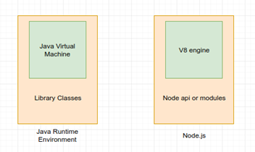

Figure 1We can see the similarity between Node.js and JavaScript

Node.js uses an event-driven, non-blocking I/O model that makes it lightweight and efficient. Node.js’ package ecosystem, [npm](https://www.npmjs.com/), is the largest ecosystem of open source libraries in the world.

I/O refers to input/output. It can be anything ranging from reading/writing local files to making an HTTP request to an API. I/O takes time and hence blocks other functions.

### Blocking I/O

In the blocking method, user2's data request is not initiated until user1's data is printed to the screen.

### Non-blocking I/O

On the other hand, using a non-blocking request, you can initiate a data request for user2 without waiting for the response to the request for user1. You can initiate both requests in parallel. This non-blocking I/O eliminates the need for multi-threading since the server can handle multiple requests at the same time.

**The JavaScript event loop**

Here’s a quick step-by-step explanation of how the JavaScript Event Loop works.

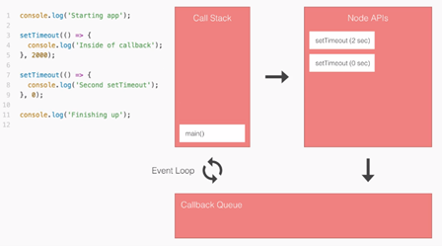

# Implementation of Node.js

Estimated Duration : 2 Days  
Actual Duration : 2 Days

## How To Implement Node.js ?

We can develop Node.js with Node / Express or Visual Studio Code. Node's Package Manager (NPM) must be installed in the environment no matter which environment it will be developed in.

## Which Environment Should We Choose?

* Visual Studio Code has support for the JavaScript and TypeScript languages out-of-the-box as well as Node.js debugging.
* Node/Express along with other libraries like template engines, database drivers, authentication middleware, middleware to serve static files, etc.)
* NPM is used to fetch any packages (JavaScript libraries) that an application needs for development, testing, and/or production, and may also be used to run tests and tools used in the development process.

*So, in Node/Express a web application creates and runs its own web server.*

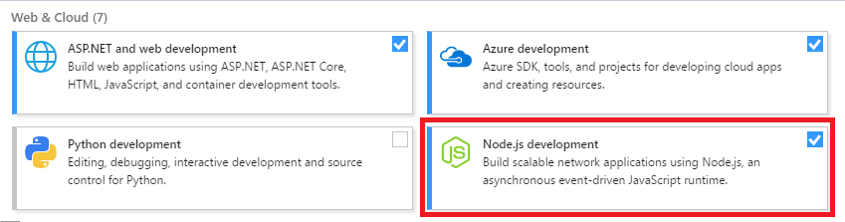

## Node.js Project Architecture

* [Create a folder structure for your project](https://blog.logrocket.com/the-perfect-architecture-flow-for-your-next-node-js-project/#rule1correctlyorganizingourfilesintofolders)
* [Use a service layer](https://blog.logrocket.com/the-perfect-architecture-flow-for-your-next-node-js-project/#rule3useaservicelayer)
* [Use a config folder to organize configuration files](https://blog.logrocket.com/the-perfect-architecture-flow-for-your-next-node-js-project/#rule4useaconfigfolderforconfigurationfiles)
* [Establish a scripts folder for long npm scripts](https://blog.logrocket.com/the-perfect-architecture-flow-for-your-next-node-js-project/#rule5haveascriptsfolderforlongnpmscripts)
* [Use dependency injection](https://blog.logrocket.com/the-perfect-architecture-flow-for-your-next-node-js-project/#rule6usedependencyinjection)
* [Conduct unit testing](https://blog.logrocket.com/the-perfect-architecture-flow-for-your-next-node-js-project/#rule7useunittesting)
* [Comment your code](https://blog.logrocket.com/the-perfect-architecture-flow-for-your-next-node-js-project/#rule11alwayscommentyourcode)
* [Keep an eye on your file sizes](https://blog.logrocket.com/the-perfect-architecture-flow-for-your-next-node-js-project/#rule12keepaneyeonyourfilesizes)

# Asking The Client Requirements About App

Estimation Duration : 2 Days  
Actual Duration : 2 Days

**My task was to ask for the application the client wanted.**

**So I have disclosed customer relations.**

**The purpose is how we can make the customer happy, how can we meet their wishes.**

How should the relations with the customer be?

* The essence of customer relationship management is to understand the differences between customers and to develop strategies for customers based on these differences and ultimately to establish lasting and profitable relationships with customers.
* Because if the customer cannot find what he wants, he / she shifts to competing products.
* In other words, it is not only the product itself, but how and in what way it will reach the customer, how to establish lasting relationships with the customer.
* We must make it possible to use the right tools that enable the customer relationship method to increase customer value and drive valuable customers to buy by keeping them loyal for life .
* Providing excellent real-time service by establishing individual relationships with customers with the help of efficient databases .
* Using technology or software solutions that help collect and track customer data to provide better customer service.
* Businesses have to be in contact with their customers and manage this relationship effectively in order to maintain their competitive position.
* In this context, the most important assistant of businesses is technology.
* Advances in technology businesses to bring more fertile the relationship with customers allows provides.
* This caused to customers are demanding more from the businesses.
* The main features of this period:
* Consumers: They turn to products with the best prices, best quality, high performance and outstanding features.
* Firms: They are product-oriented, oriented to develop the product in technological and other aspects and to increase the quality of the product.
* The point of view that summarizes this period is "Good goods do not sell themselves, they sell or buy products that are suitable for consumer demands, at an acceptable price level, well-promoted and properly distributed".

# Iterating And Testing

Estimation Duration : 2 Days  
Actual Duration : 2 Days

My task this week is to determine the testing phases of the program.

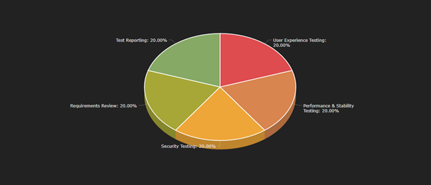

As I tried to explain in the image, I decided to examine it in 5 parts. These;

* User Experience Testing
* Performance & Stability Testing
* Security Testing
* Requirements Review
* Test Reporting

We will examine as.

As I tried to explain in the image, I decided to examine it in 5 parts. These;

* User Experience Testing
* Performance & Stability Testing
* Security Testing
* Requirements Review
* Test Reporting

We will examine as.

It is not possible for us to do all of the tests fully, of course, but if we list the first problems we see when we do trials;

The app has a version problem. It doesn't work everywhere.

* Not compatible with mobile.
* It only works with Chrome Browser, it has no integration with other browsers.
* Enter key does not work when logging in and trying to type in chat.

We noticed major problems such as. Apart from these, as a part that can be added to the application and developed;

* Password can be added,
* File sharing is not available, it can be added,
* There is a problem in the link section, it can be corrected,

may increase like.

# Last And Next Week's Working Plan

|  |  |  |
| --- | --- | --- |
|  | Last Week Working Plan  (17.03.2021-24.03.2021) | Next Week Working Plan  (24.03.2021-31.03.2021) |
| Burak Tugay Sür | Examining The Code Files To Find Its Shortcomings | Planning the application design  *Estimated Duration : 3 Days* |
| Damla Alpan | Searching Development Language | Learning about html/css  *Estimated Duration : 3 Days* |
| Doğukan Çağrı Destegüloğlu | Project Description To “Readme” File In GitHub | Searching about GitHub desktop and Git Bash  *Estimated Duration : 2 Days* |
| Ege Nur Yeşil | Implementation of Node.js | Learning about the Node.js libraries  *Estimated Duration : 3 Days* |
| Melih Cüneyter | Iterating And Testing | Keep continue testing and fixing error  *Estimated Duration : 2 Days* |
| Yeşim Gerdan | Asking The Client Requirements About App | Searching for JavaScript.  Estimated Duration : 2 Days |